Research on fast location method of network fault based on big data

Jundong Huang
Information&Communication Branch of Hubei epc,
Wuhan, China
l cc_jdhuang@163. com
Bo Jin*
Information&Communication Branch of Hubei epc.
Wuhan, China
* Corresponding author:jmjinbo@sina.com
Haohua Meng
Information&Communication Branch of Hubei epc.
Wuhan, China
176238083@qq.com
Dongling Xiao
Information&Communication Branch of Hubei epc.
Wuhan, China
l330213009@qq.com

Abstract—the stable and reliable operation of the power grid information system is the fundamental to ensure the safe production and optimal management of the power grid. In this paper, by obtaining the performance parameters of the system between load and response time, resource consumption, and introducing time, external time and other parameters for big data analysis, the performance trend analysis of throughput, error and response time is given, and the current situation and history of the system are analyzed Historical data comparison and performance bottleneck analysis can improve the level of information mining, quickly and accurately realize the location of network fault components and fault type and cause identification
Keywords- network fault location; throughput; response time; big data

Introduction
With the continuous development of China's economy, people have higher and higher requirements for the stability of the power grid. The safe and stable operation of the network system in the power grid is conducive to the improvement of the national living standard. There are many possibilities for the occurrence of network failures. First, the physical devices in the physical layer fail to connect with each other or the hardware and circuit itself; second, Interface configuration of network equipment; third, the network protocol configuration or operation error in the network layer; fourth, the device performance or communication congestion in the transmission layer; fifth, the network application program error. Due to the high connectivity of modern network, every small fault in the network may lead to more serious consequences. Among them, fault location, as the most complex and time-consuming link in fault diagnosis, plays an important role in the later troubleshooting ^{[1]}. Therefore, it is urgent to research and develop a set of fault location technology with the ability of accurate diagnosis, analysis and processing of complex and uncertain problems, which is also the research hotspot in the fields of the faults of network management ^{[2]}.
Combining with the actual network operation environment of a power company, this paper introduces the time and external time parameters of the relevant network, and based on the prediction model of wavelet neural network, gives the performance trend analysis of throughput, error and response time, and forecasts the performance bottleneck, so as to realize the location of network fault components and the identification of fault types and causes.

Related methods of fast location of network fault
At present, people pay more and more attention to the rapid location of network fault and various technical methods around it. Tan Wukun, Yang Qiuhui, Chen Wei ^{[3]} put forward a method of network fault location based on Bayesian network. Firstly, the fault propagation model is constructed in three levels, and Bayesian network is constructed through Bayesian learning; Then the real-time alarm data are grouped according to the time window, and the possible fault sets are inferred by using the metical API based on the Bayesian inference algorithm; finally, the fault inference results are evaluated by using the evaluation algorithm. Sun Yuyan and CAI Zexiang ^{[4]} analyzed the fault feature information of different monitoring nodes based on the redundant monitoring of the fault state of communication network, and proposed the representation mode of fault feature information of communication network. Based on the emergence principle, according to the physical connection, logical connection and message subscription relationship of the communication network, the automatic generation of fault samples is realized. Combined with the training rules, the communication network fault diagnosis model based on the deep confidence network is established. Based on this, the real-time fault analysis and processing flow is given. Ehsan GORD, Rahman Dashti ^{[5]} proposed a hybrid two-step method, which uses the information stored in the network before and after the fault to identify the exact fault location. Firstly, the fault distance is estimated by the voltage and current information at the beginning of the feeder. Considering the topology of the distributed network, the estimated distance will be associated with several similar parts. In the second step, based on the transient analysis of frequency component, the fault location can be located accurately. Wang Junyu ^{[6]} puts forward a fast location method of network fault data based on fuzzy approach algorithm. The system converts the current network fact alarm items into fuzzy alarm, finds all the matching close indicators in the close indicator database by fuzzy matching, and collects the close indicators with the highest matching degree as the reasoning trigger indicators. The fuzzy warning correlation information of fault data is extracted from the index, and the fuzzy warning conclusion of network fault data is deduced. Wang zhankong, Wang Xueli ^{[7]} based on the management information base (MIB) of SNMP network management model, constructed Bayesian networks for fault identification and location at different levels. The adaptive autoregressive (AAR) model is used to model and analyze the MIB variables. The Bayesian network between MIB variables and its related protocols is constructed to infer whether the protocol function is abnormal. Considering the fault propagation in the network, a Bayesian network based on network topology is constructed to locate the fault source node.

A fast fault location method based on big data
Based on the possibility of various faults in the network, a prediction model based on the control theory of wavelet neural network is proposed in this paper. By introducing time, external time and other parameters, the analysis of throughput, error and response time is obtained. By comparing the current situation and historical data of the system and analyzing the performance bottleneck, the network fault location analysis is carried out. Wavelet neural network (WNN) is a kind of feedforward neural network which combines wave transformation and BP neural network. It takes the nonlinear wavelet basis function as the sigmoid transfer function of hidden layer node, the signal propagates forward, and the error propagates back at the same time. According to the error between the actual output and the target value, the gradient correction method is used to continuously modify the network parameters so that the predicted output value is as close to the actual value as possible, and its topological structure is shown in Figure 1.
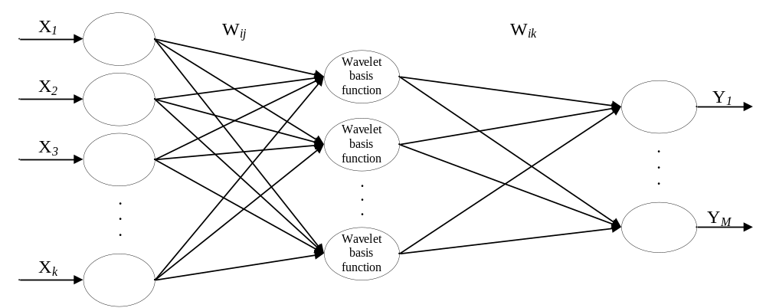
Figure 1. Topological structure of wavelet neural network
In Figure 1, X₁, X₂ ,…, X_{K} are the input variables of wavelet neural network; Y₁, Y₂ ,…, Y_{M} are the expected output values of the wavelet neural network; w_{ij} and w_{jk} are the weights of the wavelet neural network; when the input variable sequence is X_{i}, it is (I = 1, 2, 3,... , K), the calculation formula of hidden layer output is:
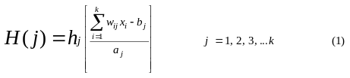
Where, k represents the number of input layer nodes; i represents the number of hidden layer nodes; H_{(J)} represents the output value of the j-th node in the hidden layer; HJ represents the wavelet basis function; a_{j} represents the expansion factor of the wavelet basis function; b_{j} represents the translation factor of the wavelet basis function; w_{ij} represents the weight between the input layer and the hidden layer. In this paper, the Morlet mother wavelet basis function is used. The mathematical expression is：
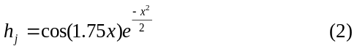
The calculation formula of network output layer is:
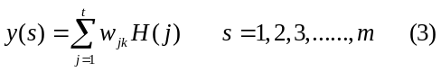
In the formula: i is the number of hidden layer nodes; m is the number of output layer nodes; Y _{(s)} is the output value of the s-th node in the output layer; w_{jk} is the connection weight between the hidden layer and the output layer; H_{(J)} is the output value of the j-th hidden layer node.
The gradient descent method is used to modify the parameters of the wavelet neural network, so that the predicted value is close to the actual value. The specific correction process is as follows:
- Prediction error of calculation model
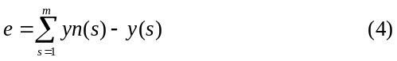
Where: y_{n (s)} is the actual value and Y_{(s)} is the predicted output value of the network.
According to the error e, the coefficients of wavelet basis function and the weights of wavelet neural network are modified.
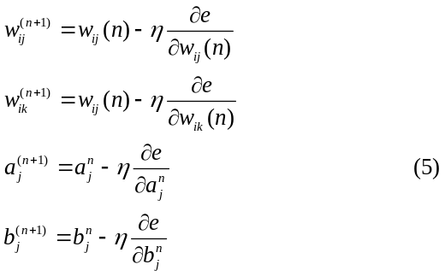
Where: η represents learning efficiency; w_{ij(n)}, w_{jk(n)}, b_{j(n)}, a_{j(n)} represent the weight, translation factor and expansion factor of the nth revision respectively.
The training steps of wavelet neural network are as follows:
1) Initialization of network model: random initialization of wavelet function translation factor b_{j}, expansion factor a_{j}, network connection weight w_{ij} and w_{jk}, and set the learning rate η.
2) Prediction output: input the training samples into the network calculate the prediction output value of the model and calculate the prediction error e.
3) Weight correction: according to the calculated error e, the weight of the network and the parameters of the wavelet basis function are corrected, so that the predicted value of the network is close to the actual value.
4) Determine whether the algorithm is finished. If not, return to step 3.

Application and analysis of network fault rapid location in power grid system
In fact, the power grid system is prone to a series of faults. The network faults in the power grid information management system will bring great losses to the society and users. Therefore, after the network is completed and operated, it is necessary to accurately locate the network faults in the system. The diagnosis of network faults is a very important technical work. The overall scheme of fault location in this paper is shown in Figure 2 。
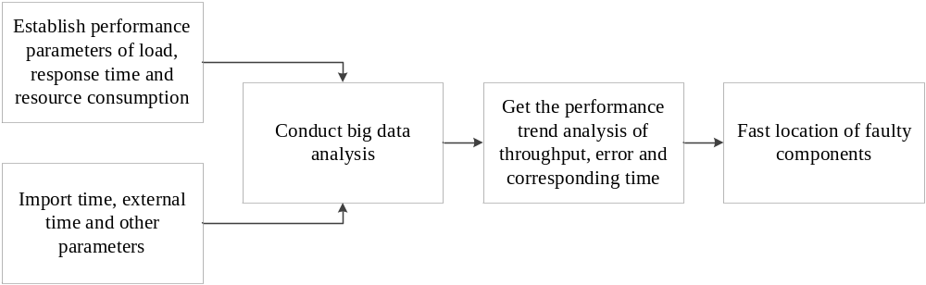
Figure 2. Overall design schemes
Firstly, the performance parameters between the load and the corresponding time, resource consumption are established. At the same time, time, external time and other parameters are introduced. Based on the prediction model of wavelet neural network, the performance trend analysis of throughput, error and response time is obtained. Then the performance bottleneck analysis of the system is carried out to improve the level of information mining, it can locate the fault components and identify the fault types and causes quickly and accurately.
Take a company as an example, in the process of system a construction, the data of system B needs to be called, and in the calling process, F5 needs to be used for load balancing, but after the load balancing configuration, the pressure of server a in system B increases sharply, and the load of server B is not large. The possible causes are system a configuration error, direct configuration to system B address, F5 configuration error, and unequal data distribution. In order to analyze and locate the problem, the data time used in this paper is from 18:15 on November 19, 2015 to 18:45 on November 19, 2015. The wavelet neural network prediction model is used to input the time and external time of the data in this period, and the continuous 30 minute data is used to output the throughput, error and response time to get the bottleneck analysis of the network performance, so as to realize the network failure Location of barrier elements and type of failure. Figure 3 and Figure 4 are the analysis result network interface.
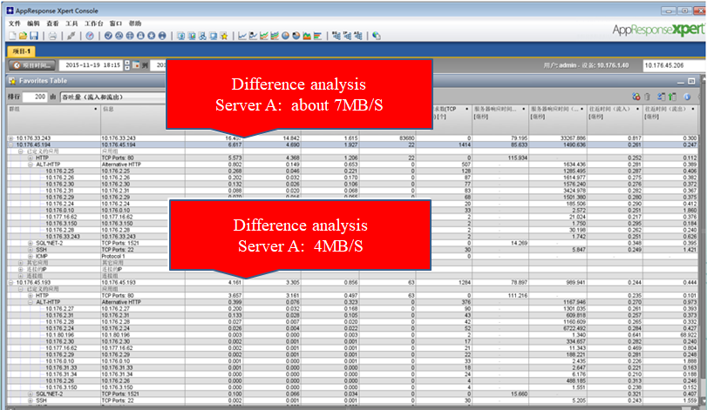
Figure 3. Analysis results
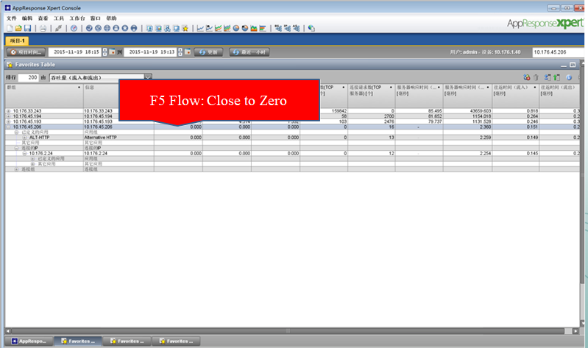
Figure 4. Analysis results
Through the analysis of the data collected by the wavelet neural network prediction model, it is found that the performance trends such as throughput, error and response time can be well obtained. It can be seen that the difference between server A and server B is 7MB / s, 4MB / s and almost no F5 traffic. Thus, the location of network fault is known, which shows that the prediction model has a good fault location effect.

V. Conclusion
Based on the comprehensive consideration of a series of network faults in the power grid information management system and its causes, this paper takes various parameters of the system as the research object when the network faults occur, studies and analyzes the existing network fault location methods, and puts forward a fast network fault location method based on big data, which is based on the prediction model of wavelet neural network On the basis of the above, the location and type of network fault in the power grid information management system are diagnosed and located. This method can effectively locate the fault.

Acknowledgment
This work was supported by the information project of Central China branch of State Grid Corporation of China (Project Name: Central China branch of state grid information system performance automation analysis tool development and implementation project).

References
- Ramana Rao Kompella.Fault Localization in Backbone Networks[D].San Diego:University of California,2007
- Breitbart Y, Garofalakis M, Jai B.Topology discovery in heterogeneous IP networks:the net inventory system[J].IEEE/ACM Transactionson Networking, 2004, 12 (3) :465-476.
- Tan Wukun, Yang Qiuhui, Chen Wei. Fault location method of communication network based on Bayesian network [J]. Computer application, 2018,38 (S2): 217-220 + 235.
- Sun Yuyan, Cai Zexiang, Guo Caishan, Ma Guolong, Dai Guanquan. Fault diagnosis and location method of intelligent substation communication network based on deep learning [J]. Grid technology, 2019,43 (12): 4306-4314.
- Ehsan Gord,Rahman Dashti,Mojtaba Najafi,Athila Quaresma Santos,Hamid Reza Shaker. Determining an accurate fault location in electrical energy distribution networks in the presence of DGs using transient analysis[J]. Measurement,2020,151.
- Wang Junyu. Research on network fault management system based on alarm correlation [J]. Journal of Hunan Taxation College, 2016,29 (04): 54-56.
- Wang zhankong, Wang Xueli. Hierarchical network fault diagnosis based on Bayesian network [J]. Software, 2011,32 (04): 87-90.

